ASSIGNMENT OP. TRACK

B C SACHIN

ASSIGNMENT 1: PROMETHEUS AND GRAFANA

STEPS To install Prometheus:

STEP 1: INSTALL PROMETHEUS ON VIRTUAL BOX

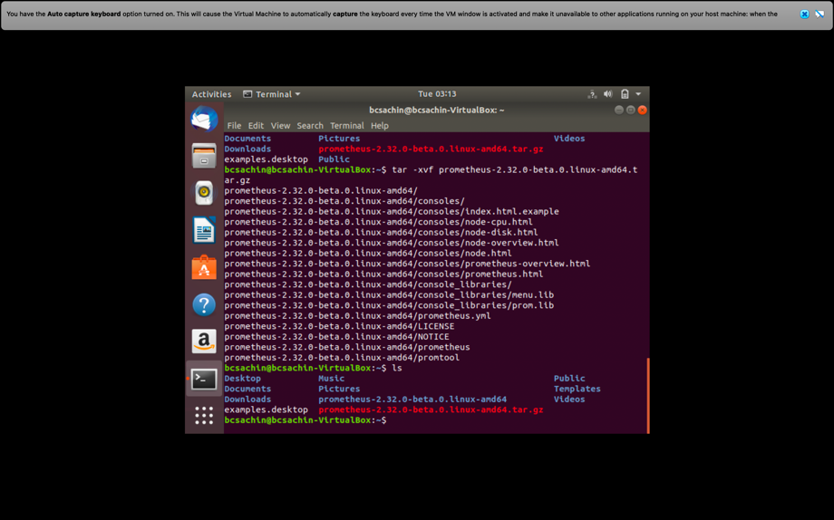

* Prometheus installed

STEP 2: START PROMETHEUS USING “./prometheus”

STEP3:OPEN BROWSER AND TYPE <http://localhost:9090>

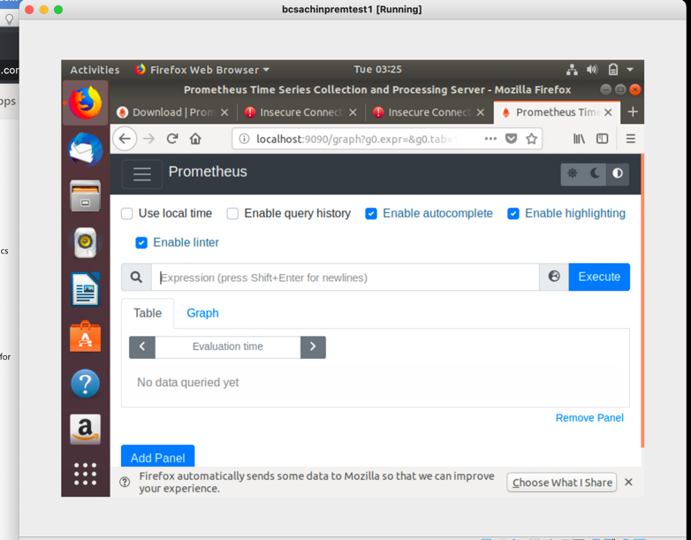

* As we can see the terminal up and running

STEP4: NOW CREATE SERVICE FILE TO RUN THIS AS A SERVICE

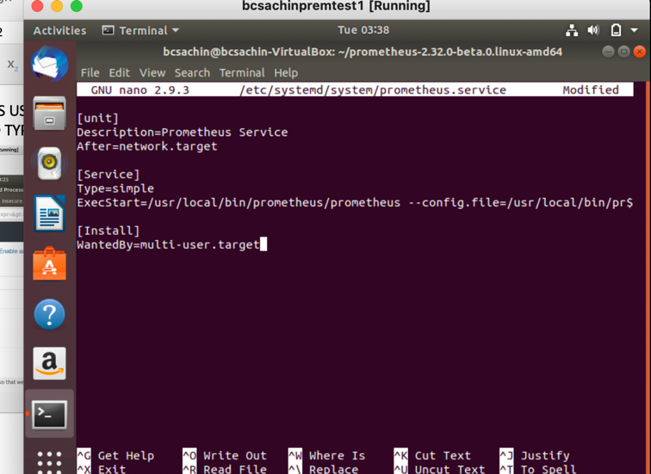

*sudo cp -r . /usr/local/bin/Prometheus

*sudo nano /etc/system/system/Prometheus.service

Add the following lines as shown in the image

*systemctl daemon-reload

*sudo service start Prometheus

It will prevent from service stoping whenever terminal closed

STEP5:NOW INSTALL NODE EXPORTER FOR MONITOR

 AND COPY NODE_EXPORTER FILE TO /usr/local/bin. Where our Prometheus situated

STEP6: Now create service node-exporter.service

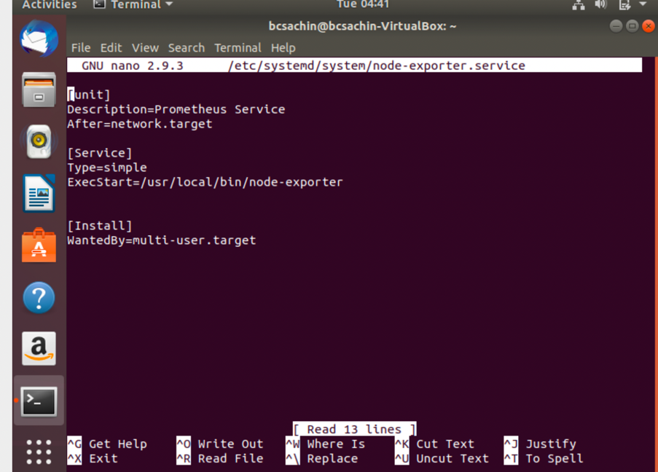

* Node-exporrter service

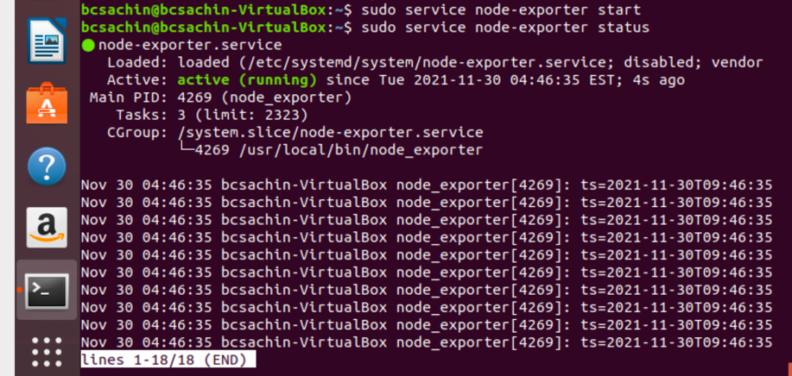

* Start the service

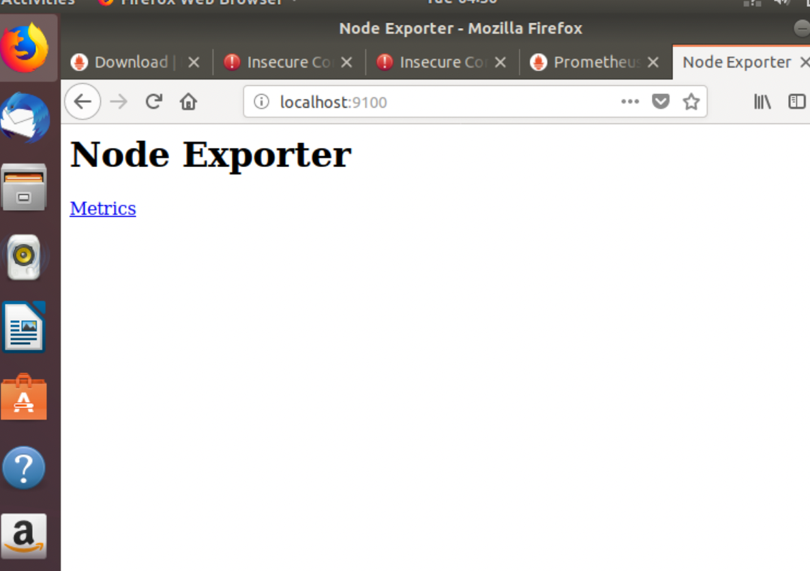Now add job in Prometheus

*NODE EXPORTER Up and running on port 9100

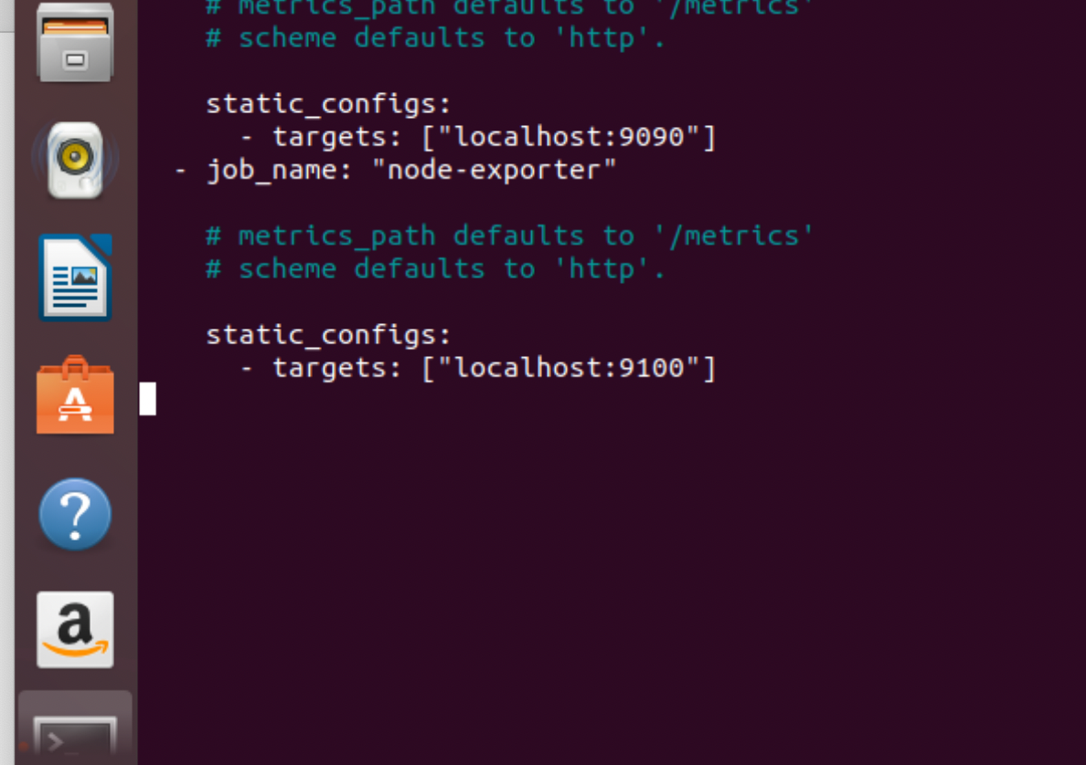

To update The node exporter add new job in Prometheus.yml

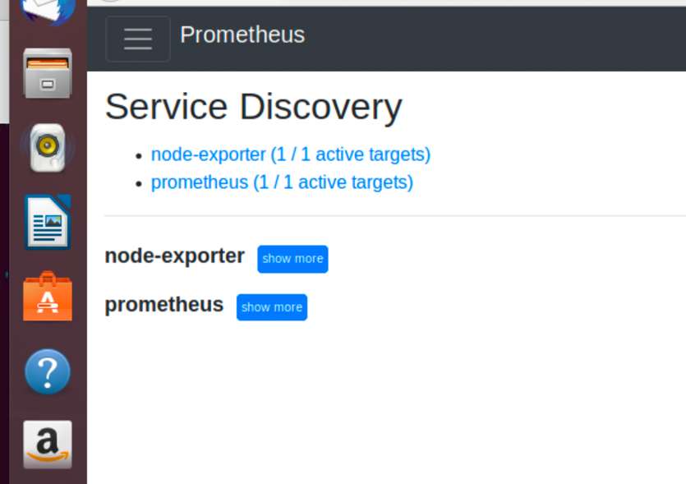

Restart the Prometheus

Now service directory added

(alert manager and Grafana installed steps are mentioned in upcoming question step)

Question 2:

* Create rule for get query
* “./promtool check rules <rulefile.yml>” command used to check error in file

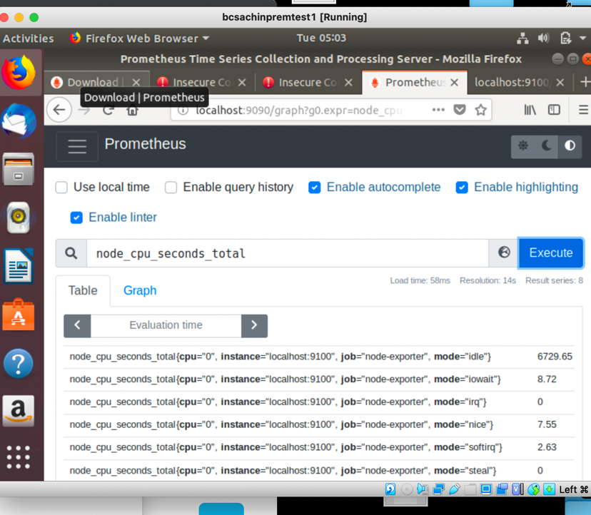

Node_cpu_seconds_total. Used to get performance of cpu

Here *

* ”user” the time spent in userland

* ”system”-time spent in kernel

* ”softrq”-for interrupts

* ”steal”-time vm taken from my cpu

* ”idle”: cpu has nothing to do

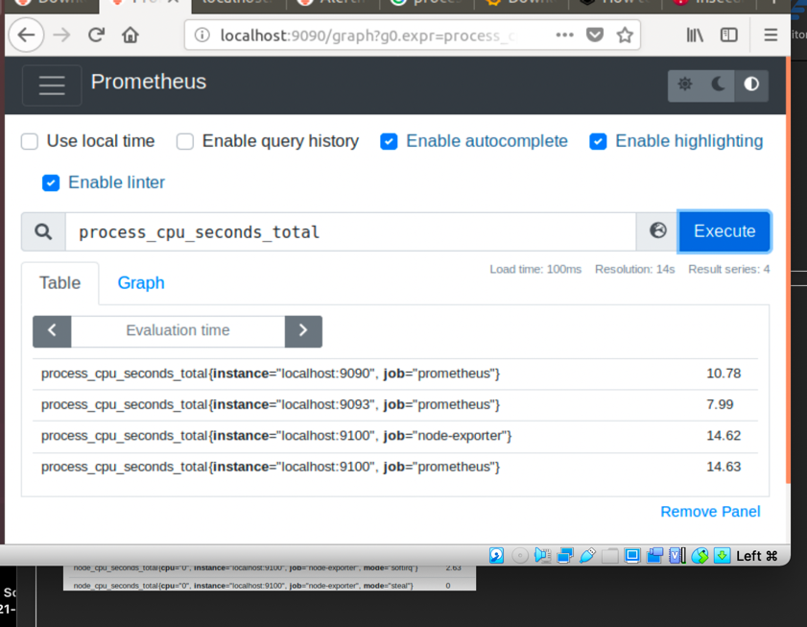

*Process_cpu_seconds_total

* this is used to check process utilization by system

Question 4:

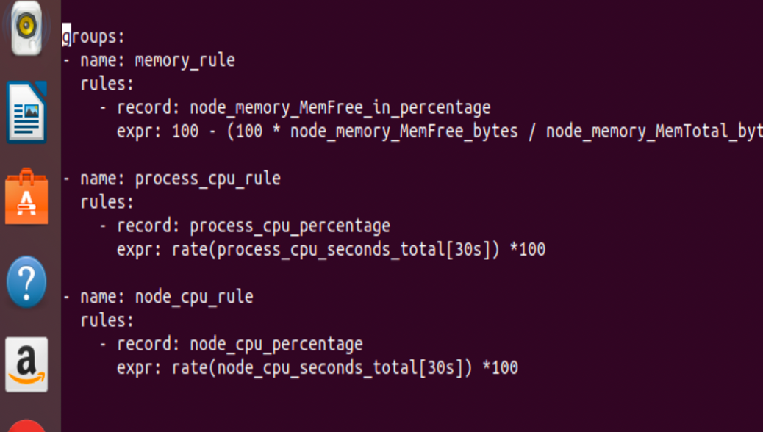Create own rule and alert for monitor memory and cpu

Step 1: CREATE RULE as shown below

1. For memory
2. For cpu seconds
3. For node cpu seconds

d.Check rule using promtool

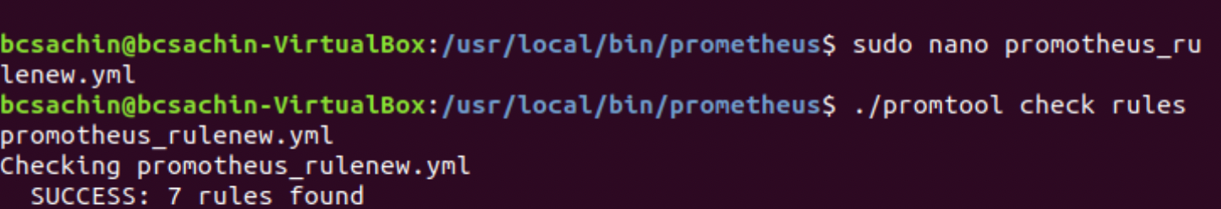

*Now install alertmanager using link present in official Prometheus web site

*start the service which will be available at port 9093

*add rule and alertmaneger in Prometheus.yml in rule and alertmanager section respectively

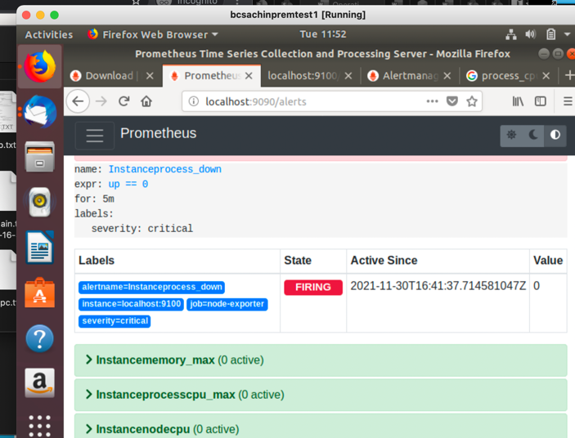Now alert rules looks like:

ALERT FOR INSTANCE STOP FOR 5 MIN

A

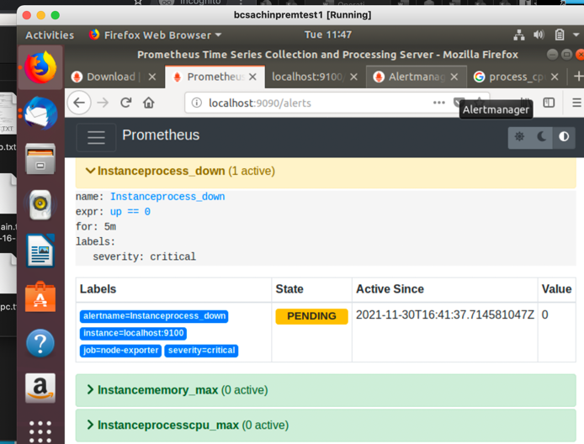

ALERT IN PENDING STATE

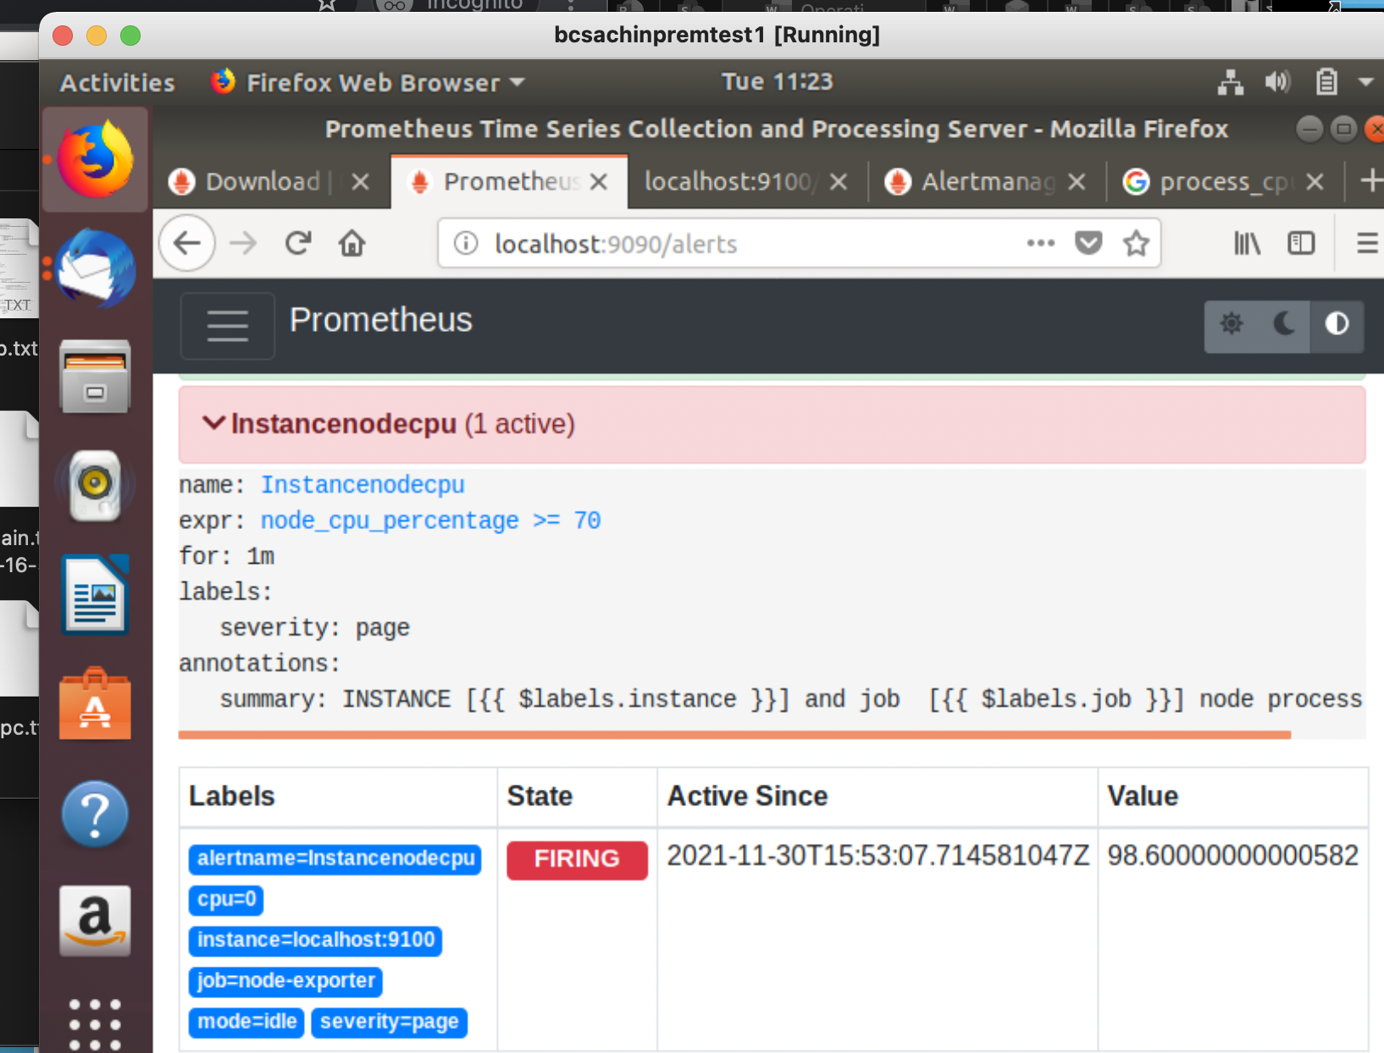 ALERT FOR NODE PERCENTAGE CPU

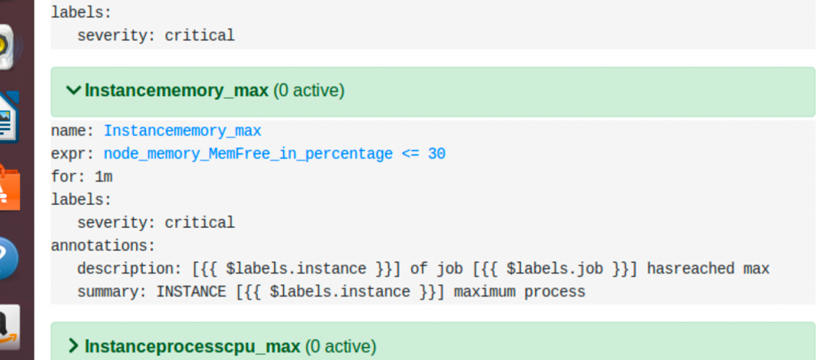

ALERT FOR MEMORY

IF FREE MEMORY BECOME LESS THAN 30 IT WILL BE 70% USAGE

QUESTION 6:

ADD EMAIL IN alertmanager.yml

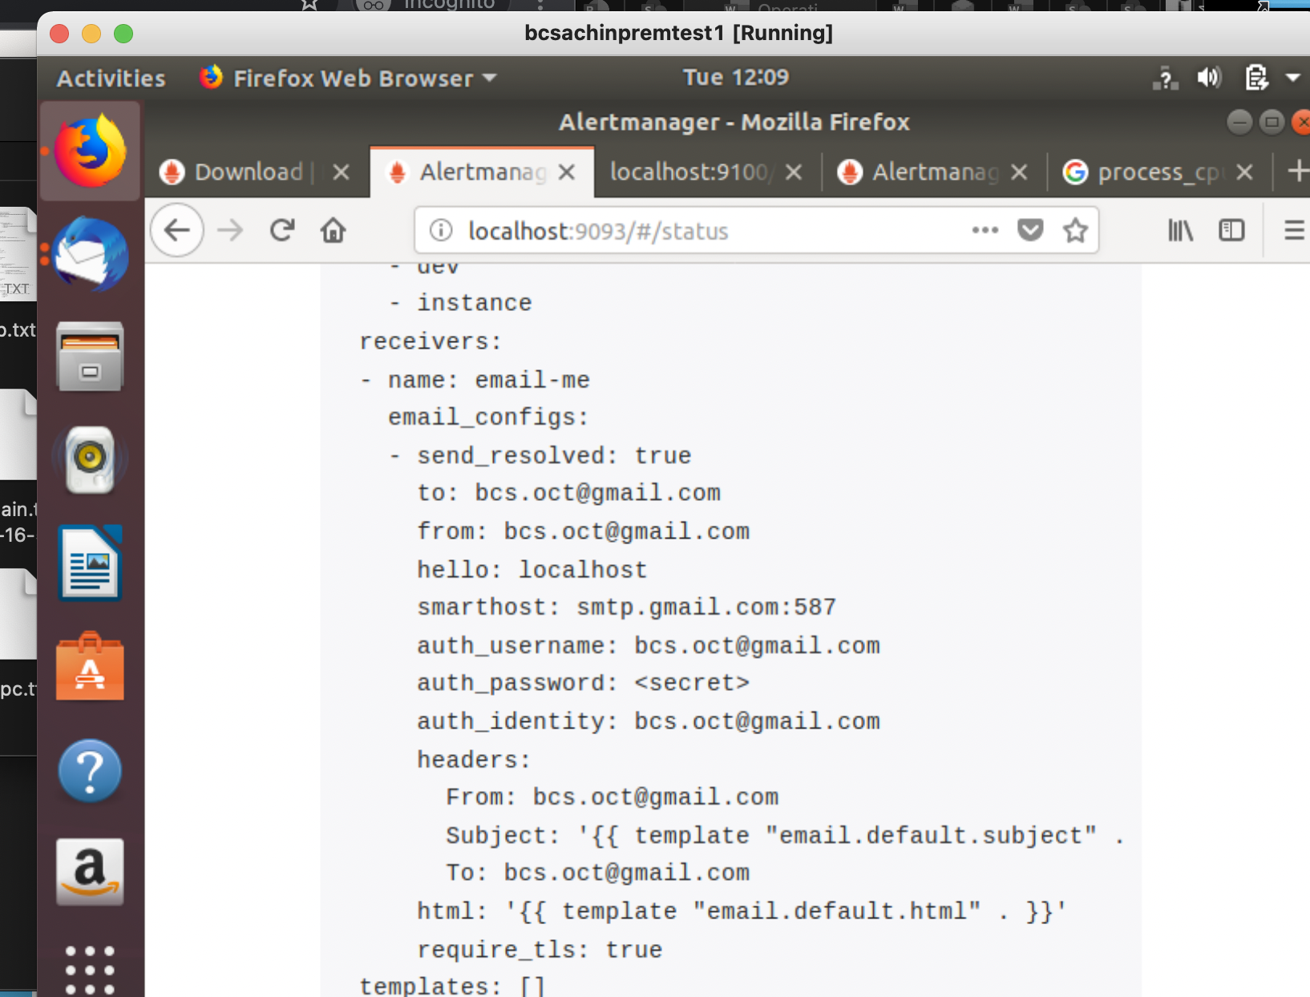

Whenever the status will be fire in alertmanager it will fire the mail

RESULTS:

Q1: SETUP PROMETHEUS , ALERT MANAGER AND GRAFANA

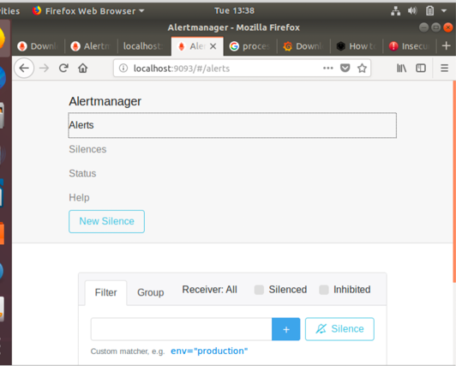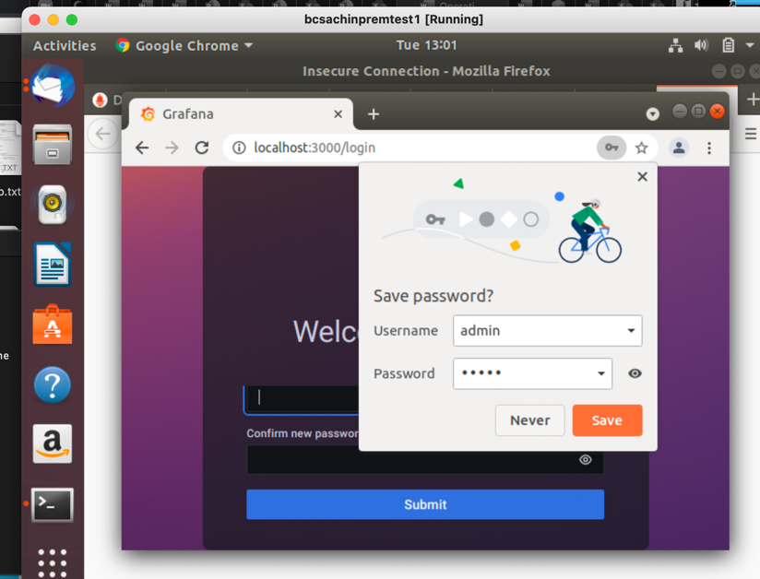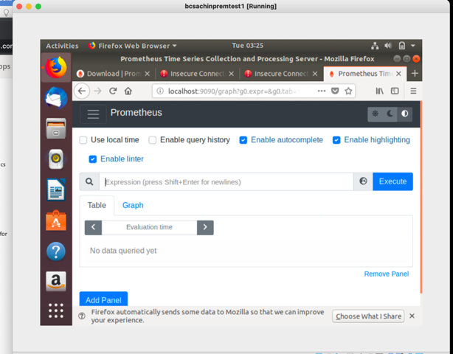

Alertmanager

Prometheus Grafana

Q2:Query to get system performance

* Process_cpu_seconds cpu utilization in the instance
* Node_cpu_seconds_total

To get cpu utilization detail as follow

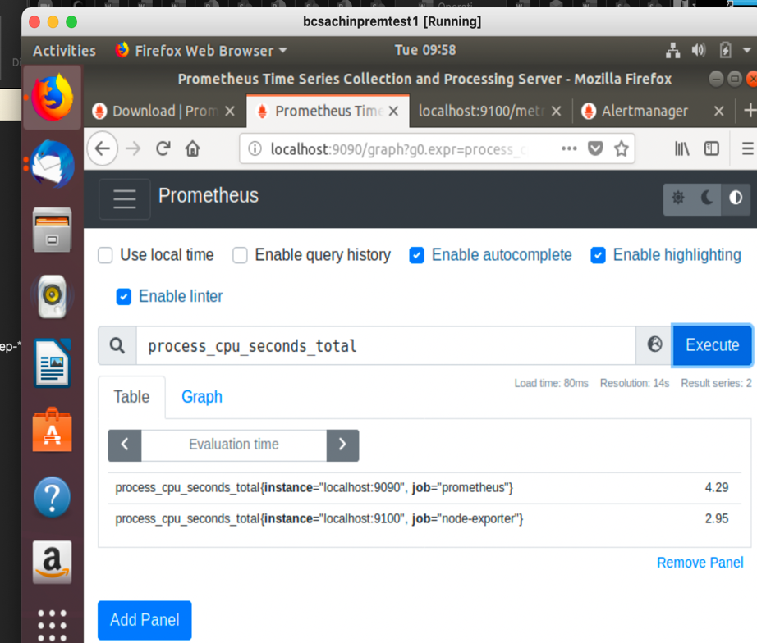

This rule created using expression

rate(process_cpu_seconds_total[30s]) *100

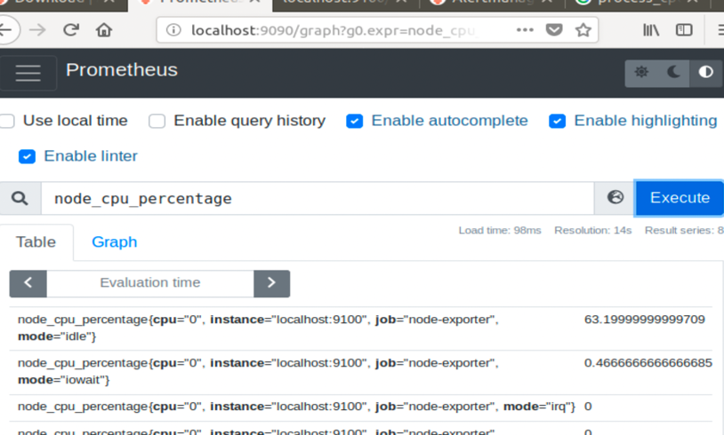

* Node cpu utilize percent
* Calculated using

rate(node_cpu_seconds _total[30s])*100

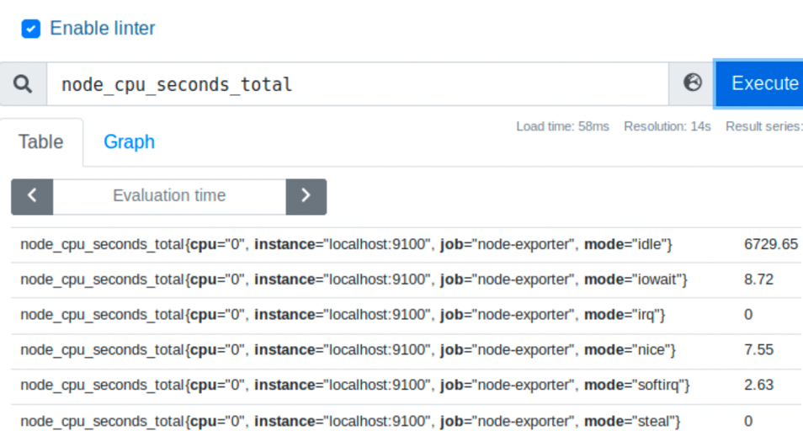

* default query cpu performance



* Cpu process of premethius and node port

QUESTION 4:

Alert set using alert manager as mentioned in step section 4th question

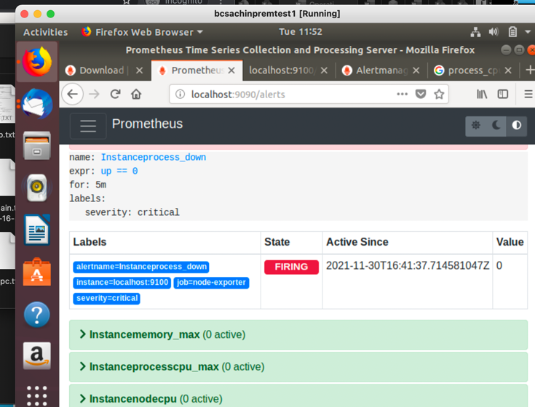

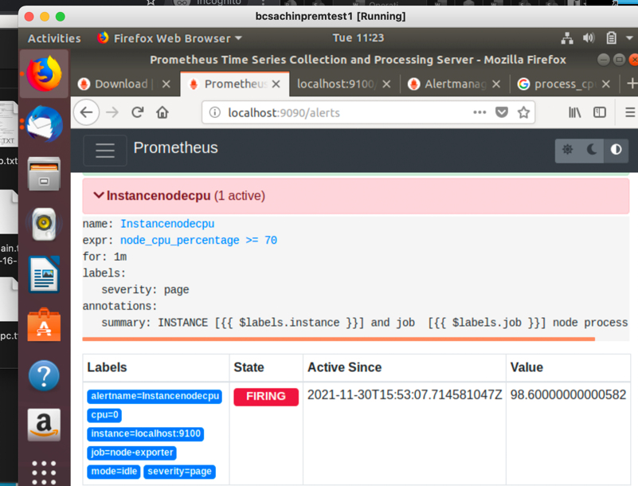

Question 5: similar to Question 4 instance down method but target should be domain hashedin.com

///GRAFANA

QUESTION 1: INSTALL GRAFANA

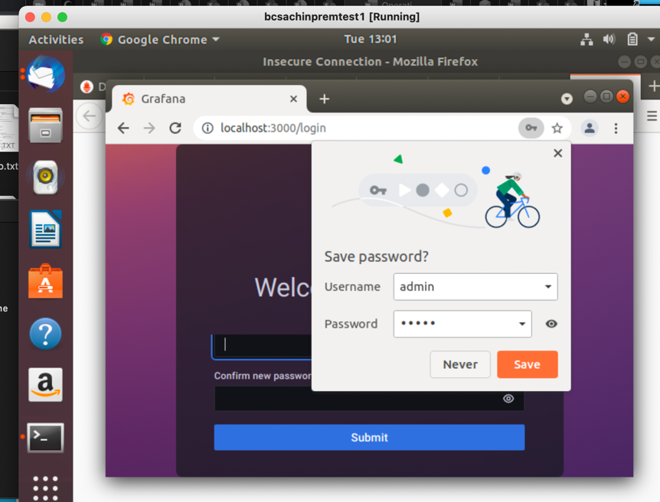

QUESTION 1 B: DASHBOARD

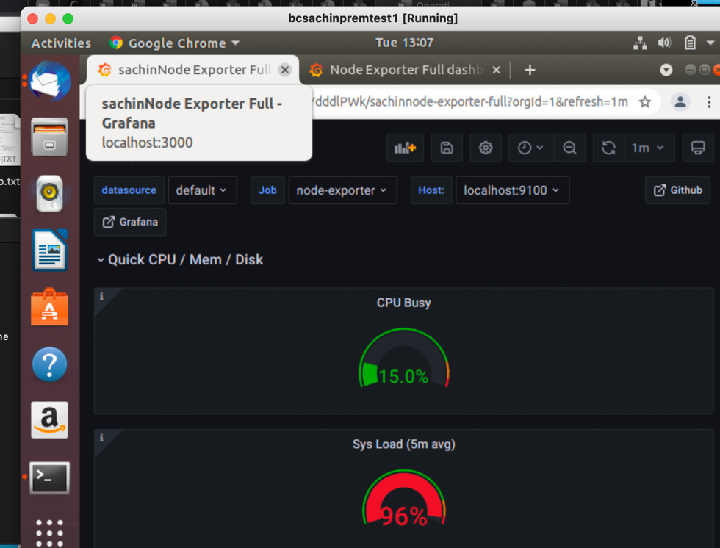

/////. APM Assignment’’

STEP1: Open Aws console and navigate to iam and serach for aws-elasticbeanstalk-ec2-role.

STEP2: Click on the role and attach inline policy to access DynamoDB

The policy json contain

{

"Version": "2012-10-17",

"Statement": [

{

"Sid": "ScorekeepDynamoDB",

"Effect": "Allow",

"Action": [

"dynamodb:PutItem",

"dynamodb:UpdateItem",

"dynamodb:DeleteItem",

"dynamodb:GetItem"

],

"Resource": "arn:aws:dynamodb:regionname:accountid:table/scorekeep-*"

}

]

}

Step4: Now download elastcbean app from given link

Step 5: create application after uploading files

Results: check health is ok

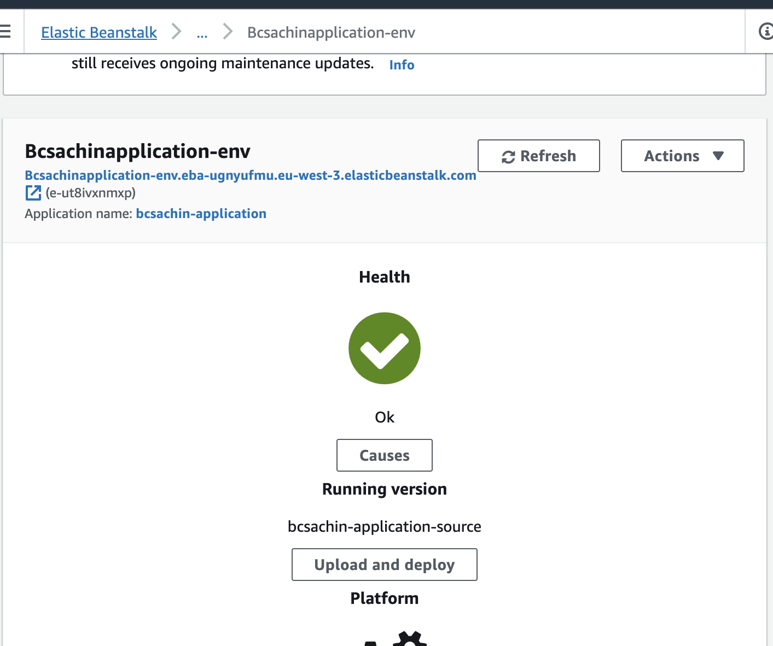

Now goto service map in xray

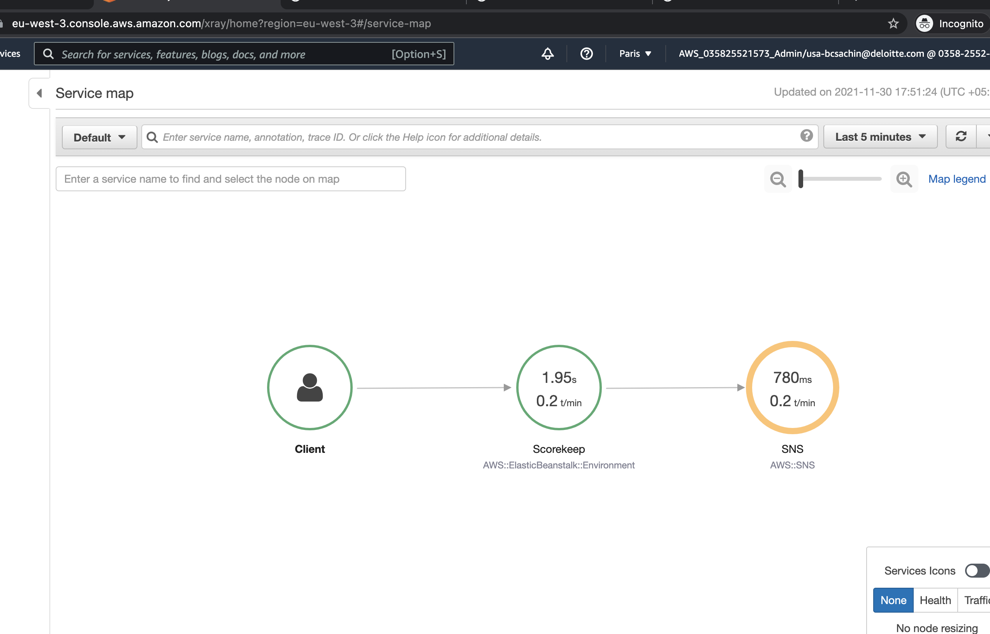

And database table created

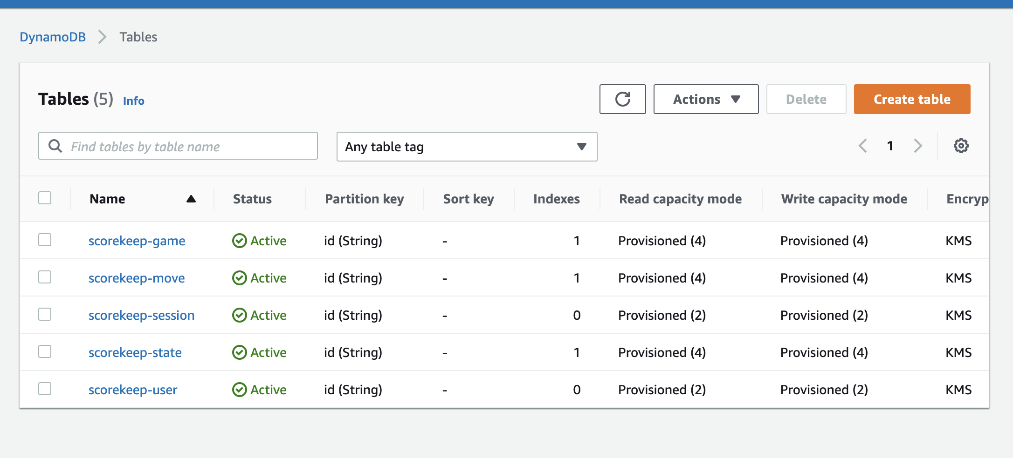

//FINISH

echo "# operationtrack" >> README.md

git init

git add README.md

git commit -m "first commit"

git branch -M main

git remote add origin https://github.com/BCSACHINHU20/operationtrack.git

git push -u origin main